# Control Mechanism of Gyroscope

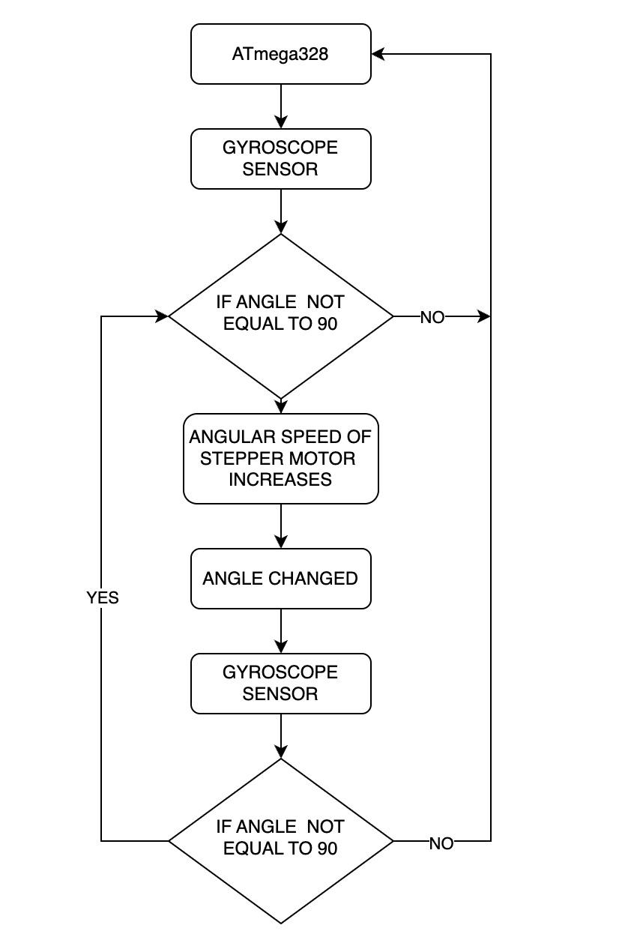

With the help of ATMEGA-328, gyroscope sensor detect the orientation of our CANSAT. If the angle detected by gyroscopic sensor is not equal to 90 $°$ i.e., our CANSAT is not perfectly straight then the angular speed of stepper motor attached to our gyroscope increases and thus our gyroscope applied force on the CANSAT to make it perpendicular. The angular speed increases uptill the CANSAT is not aligned perpendicularly.

Once our CANSAT is aligned perpendicularly the angular speed of stepper motor remains constant. Whenever an external force is applied to our CANSAT, accordingly the speed of stepper motor increases or decreases in order to align our CANSAT 90 $°$.

